RECREATIONAL SPONSOR FORM

BGYSA is gearing up for the 2016 Fall Recreational Soccer season. Last year we had nearly 900 youth playing in our League. We need YOUR support to keep our program strong. The growth of our association has been made possible through the generosity of people like you who care about our area’s youth.
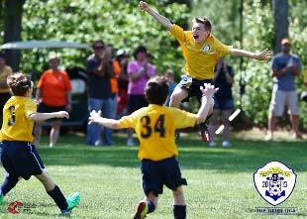
As a valued sponsor, your company's name will appear on your team's jerseys and will be seen by upwards of 2,500 prospective customers each week. Your name will also appear in the THANK YOU NOTE in the Bargain Buyer, and you will receive a plaque with your team's picture on it which you can display in your place of business.

We invite you to become a part of our growing youth soccer program. We are looking to sponsor 85 to 90 teams this year. Please send your check (made payable to BGYSA) for only $150.00 today. Sponsors wishing to support three (3) teams the fee is $400 and $100 for each additional team.

Business Name: Contact Person:

Address: | Company Name to Print on Jersey:
Telephone: ( ) ‐ | Amount Paid: $
1st Choice – Name of Child ‐ Age Group:
2nd Choice – Name of Child ‐ Age Group:
3rd Choice – Name of Child ‐ Age Group:

Use multiple copies of this form for multiple teams.
Please send a check to the address above along with this Sponsorship Form no later than June 30th to allow for printing lead times.
BGYSA operates an informative and often visited website and Facebook page. We can place your business advertisement here for a small fee of $50 per year. Please check here if you would like a link to your website and include fee with your sponsorship. Your company’s website address:

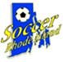
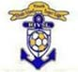
WWW.BGYSA.ORG
Since 1981, BGYSA has been providing the opportunity for area youth to enjoy the spirit of teamwork and camaraderie while learning the skills of recreational soccer. The player will often progress into more competitive teams and become prepared for middle and high school levels of play.
PO Box 235, Chepachet, RI 02814

